The Green Mantra – Website Revamp Blueprint
Implementation guide for layout, content placement, colors, and motion (v1)
Generated: 2026-02-06

1. Design intent and constraints
• Keep the site simple (same 5 pages) and keep a single primary CTA: Contact / Send form.
• Use existing brand palette (orange / yellow / greens / red). Avoid any purple-gradient 'AI look'.
• Make the site feel like a modern brochure: bold color bars, clean white sections, strong product visuals.

2. Information architecture
Top nav pages: Home, About, Products, Projects, Contact.
Footer repeats: quick links + 2 contact blocks (Asia + Africa) + email(s).

3. Brand style guide
3.1 Color palette (hex)
• Orange (header bars / highlights): #ED7429
• Yellow (accent / hero panels): #FDBF01
• Light green (section fills / badges): #94BC58
• Dark green (CTA hover / headings): #248C4E
• Red (logo / CTA emphasis): #E14539
• Teal (secondary accent): #346A68
• Maroon (secondary accent): #832820
• Off-white (background): #F7F7F7
• White (cards/background): #FFFFFF
• Charcoal (text): #222222
• Gray (borders): #DDDDDD
3.2 Typography
Headings: Poppins / Montserrat (600–700 weight).
Body: Inter / Open Sans (400–500 weight).
H1 ~ 44–56px desktop (32–40px mobile), H2 ~ 28–34px, body ~ 16–18px, line-height 1.5–1.7.

3.3 Layout grid
Max content width: 1120–1200px. Side padding: 24px desktop, 16px mobile.
Section vertical padding: 64–80px desktop, 40–56px mobile.
Card radius: 12–16px. Border: 1px #DDDDDD. Shadow: subtle (0 6px 20px rgba(0,0,0,0.08)).

4. Motion / animation (keep subtle)
• On-scroll: fade-up + slight translateY (12–16px), 350–450ms, ease-out.
• Buttons: hover darken (or switch to dark green) + slight lift (2px).
• Product cards: hover raise + shadow; image zoom max 1.03.
• Respect prefers-reduced-motion: disable transforms/animations.

5. Core components
5.1 Header / navigation
Left: logo. Right: nav links. Sticky on scroll (optional), white background.
Active page: underline in green (#248C4E) or orange (#ED7429).

5.2 Primary CTA button
Text: “Contact Us” (site-wide).
Style: solid orange (#ED7429) with white text; hover: dark green (#248C4E).

5.3 Product card
Structure: image/thumbnail → product name → 1–2 line description → optional “Details” (accordion).
Keep all products on same page (no extra pages) to maintain simplicity.

5.4 Proof / credibility strip
Use 2–4 items max: IPRs / Patents, Compostability test (ISO 17088), Circular economy, Aerobic degradation.
Display as small icon + label cards, or a single band with 3 bullet points.

6. Page-by-page layout + content placement
6.1 Home page
Section order:
HOME-01 Header/Nav
HOME-02 Hero (Value proposition + Contact Us button + hero visual)
HOME-03 Mission / Intro (short paragraph)
HOME-04 Flagship Products (7 cards)
HOME-05 How it works (Aerobic degradation process)
HOME-06 Trust / Innovation & IPRs (patent + test results)
HOME-07 Footer (Contact blocks + quick links)

6.2 About page
ABOUT-01 Header/Nav
ABOUT-02 Intro headline + short paragraph (use About text)
ABOUT-03 Our approach (R&D → product dev → commercialization) as 3-step row
ABOUT-04 Innovation & IPRs section (patents / trademarks / copyrights)
ABOUT-05 Footer
6.3 Products page
PRODUCTS-01 Header/Nav
PRODUCTS-02 Page headline + 1 line intro
PRODUCTS-03 Product grid/list (7 cards)
PRODUCTS-04 Proof strip (optional)
PRODUCTS-05 CTA strip → Contact Us
PRODUCTS-06 Footer
6.4 Projects page
PROJECTS-01 Header/Nav
PROJECTS-02 SDG alignment hero (use SDG grid visual once here)
PROJECTS-03 Key initiatives (e.g., Tirupati project, Africa 15B initiative) as 2–3 feature blocks
PROJECTS-04 CTA strip → Contact Us
PROJECTS-05 Footer
6.5 Contact page
CONTACT-01 Header/Nav
CONTACT-02 Contact form (Name, Email, Subject, Message)
CONTACT-03 Contact info blocks (Asia + Africa)
CONTACT-04 Footer

7. Content blocks (copy to place)
7.1 Home hero copy (recommended)
Headline: “Compostable alternatives to single-use plastics.”
Subhead: “Research-backed biodegradable products (bags, bottles, films, and more) designed for a circular economy.”
Button: “Contact Us”

7.2 About text (from notes)
At The Green Mantra, we are driven by extensive research and a commitment to developing innovative, eco-friendly products that serve as alternatives to single-use plastics (SUPs). Our dedication to sustainability has led us to secure a range of Intellectual Property Rights (IPRs), including patents, trademarks, and copyrights, solidifying our expertise in this vital area. The inspiration for our eco-friendly alternatives emerged from the creative minds of our dedicated promoter team. We have diligently progressed through every stage of the journey, from idea incubation and rigorous R&D to product development and commercialization; receiving invaluable support along the way. Our focus on environmental stewardship and innovation positions The Green Mantra as a trusted and capable partner in the pursuit of large-scale plastic reduction initiatives. Together, we aim to create a cleaner, greener world for future generations.
7.3 Flagship products (card copy)
• BIO-BAG: Compostable carry & shopping bags. Plant-based, sturdy, breaks down under composting.
• BIO-BOTTLE: Compostable packaged drinking-water bottle. Returns to earth after use.
• BIO-POT: Compostable nursery bag for raising tree saplings; decomposes naturally after transplanting.
• BIO-PAD: Compostable sanitary napkins and hygiene products; reduces plastic waste from conventional pads.
• BIO-BIN: Compostable garbage and waste collection bags for eco-friendly organic waste handling.
• BIO-PACK: Compostable flexible-packaging films; maintains freshness while biodegrading safely.
• BIO-RESINE: Compostable granules/masterbatches for manufacturing finished compostable goods.
7.4 Contact blocks (from notes)
Asia (Commercial arm): M/s. VERTEX ENTERPRISES, MANTRA Campus, # 3-7-62/1, Southendpark, Mansoorabad, L.B. Nagar, Hyderabad – 500061, India. Phone: +91 8328134160. Email: ao.vertexenterprises@gmail.com | info.thegreenmantra@gmail.com
Africa (Commercial arm): THE GREEN MANTRA INTERNATIONAL LIMITED, Suit No. 1D, TRV Office Plaza, 52 Muthithi Road, Westlands, Nairobi, Republic of Kenya. Phone: +254 798453818, +254 705887562. Email: admn@thegreenmantra.com | info.thegreenmantra@gmail.com
8. Visual references
Wireframe annotations are included below for developers.

Home wireframe (annotated)
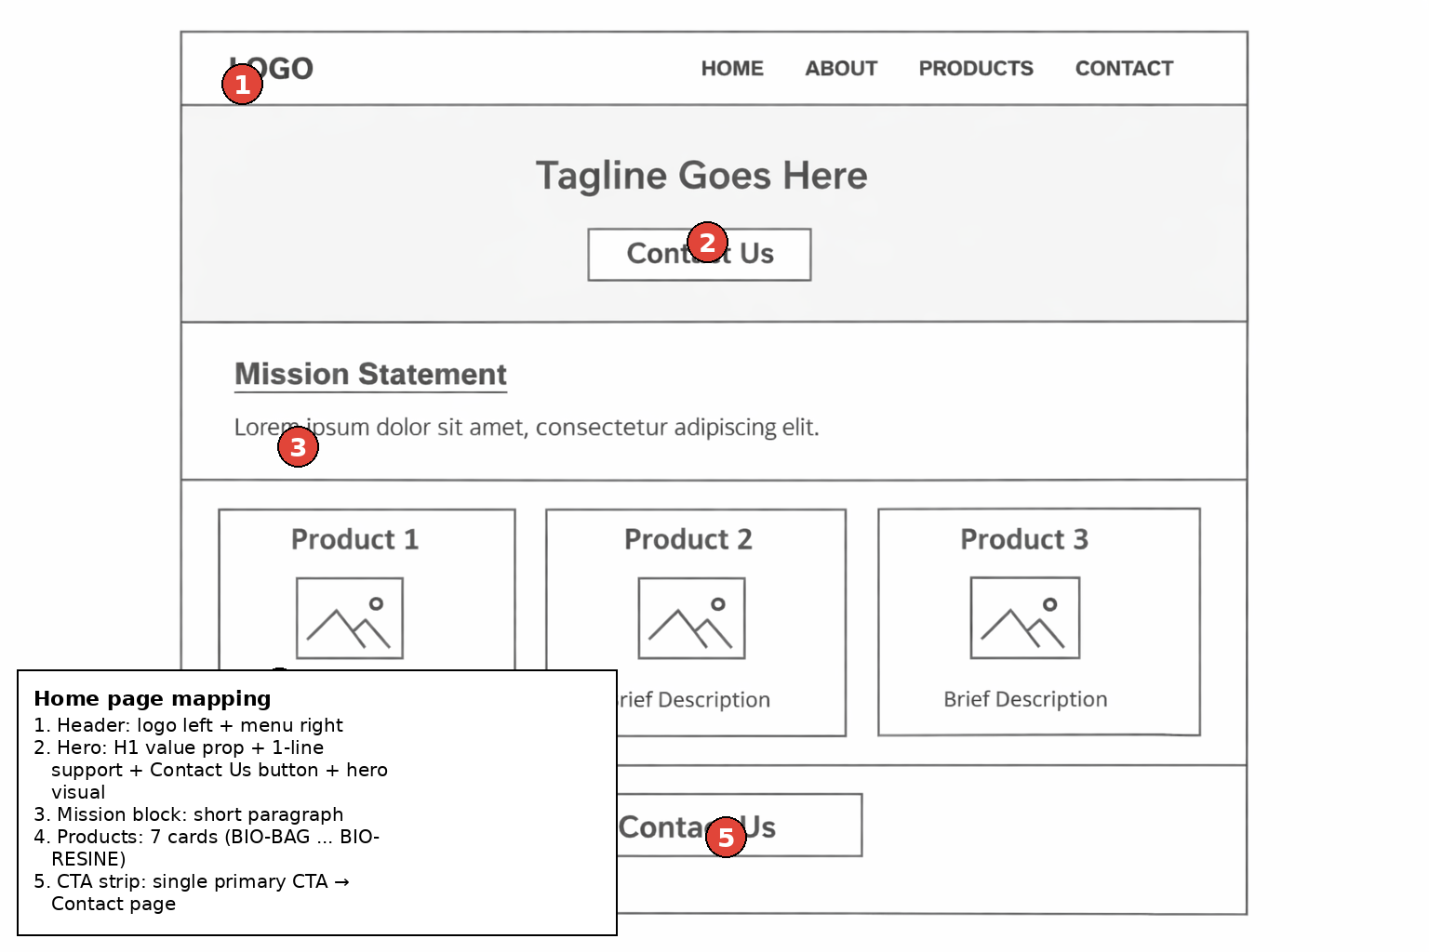

Products wireframe (annotated)
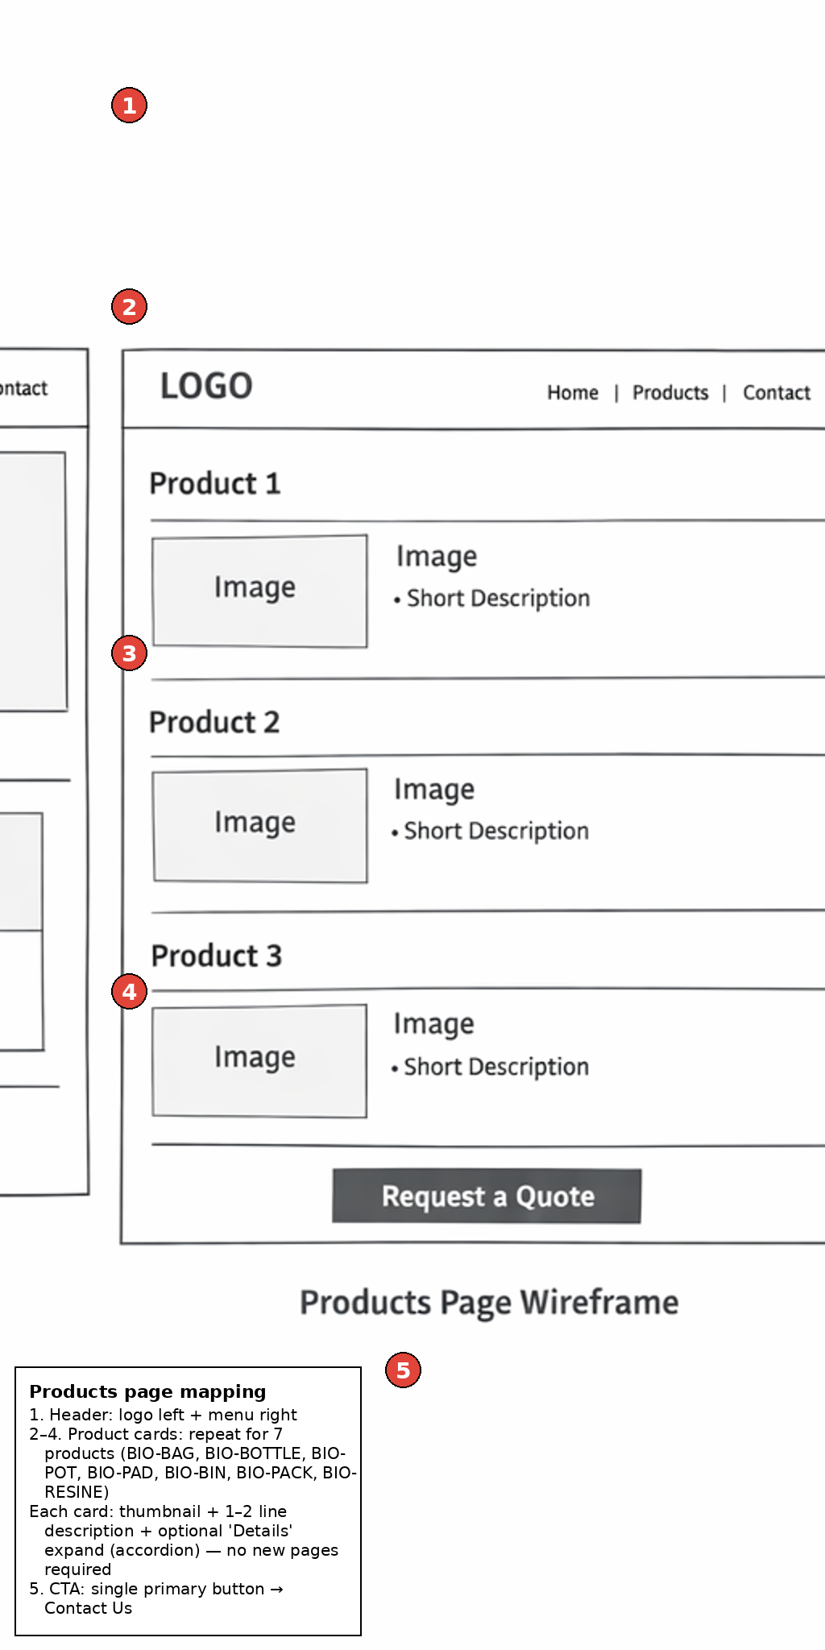

Contact wireframe (annotated)
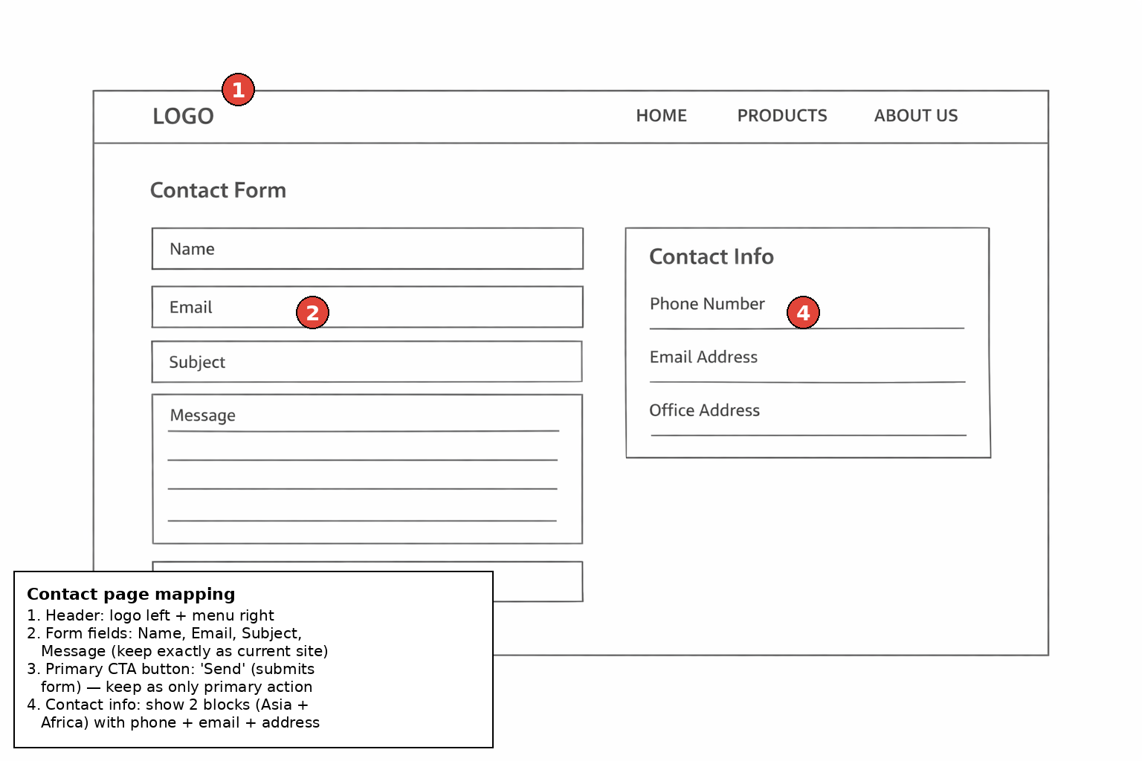

9. Asset placement map (use brochure visuals)
Use the brochure PDF images as your primary visual system. Below is a recommended mapping by page.
• Global logo / brand lockup: 0.pdf page 11 (large logo with flowers/grass).
• Home hero visual: Option A: lifestyle photo from PPT screenshot (woman holding tote). Option B: 0.pdf page 2 flagship collage.
• Home – Flagship products strip: 0.pdf page 2 (flagship products collage).
• Home – How it works / composting process: 0.pdf page 4 (aerobic degradation sequence: fragmentation → degradation → compost & plant germination).
• Home – Circular economy / lifecycle: 0.pdf page 5 (product life-cycle circular diagram).
• Home/About – Innovation & IPRs proof: 0.pdf page 6 (BIO-BAG patent/innovation spread) + page 8 (BIO-BOTTLE & BIO-POT patent spreads).
• Home – Compliance / test results: 0.pdf page 7 (ISO 17088 test results table + bullet highlights).
• Projects page – SDG alignment: 0.pdf page 1 (SDG grid). Use only on Projects page to avoid repetition.
• Projects page – Case/project imagery: 0.pdf page 9 (Tirupati project imagery) and page 10 (Africa 15B initiative / join hands with nature).

10. Developer checklist
• Responsive: stack columns on mobile; keep cards 1 per row on small screens.
• Performance: compress images, lazy-load below the fold, use WebP where possible.
• Accessibility: contrast, focus states, alt text for all brochure images.
• Forms: keep fields simple; validate; show success/error messages.
• Consistency: only one primary CTA style (Contact Us / Send).

